**Idea**

**XXX** is an app that bridges the gap between companies and photographers and videographers. Companies can reach out to our crowd to request media that those companies will use for advertisement purposes. Users from the crowd will upload the media content on our app and our moderators will filter the top 10, top 50 and top 100 uploads that suit the company’s request best and provide them to the company. If the company likes the content being provided, it will reach out to the creator and buy his/her content. If the company does not buy any video being provided, the videos will be shown to other buyers to whom the category might fit. Users will be categorized such that companies can find it easier to find specific videographers and photographers of their choice.

**How Idea meets customer needs**

Getting authentic, custom made photography for brands is fragmented, expensive and hard. The stock photo industry uses mass archives of irrelevant, outdated, pre-shot photos. Searching for the right photo is inefficient and sometimes impossible.

**Target Market demographics**

After text messaging (86%) and email (83%), photos and videos (71%) is the most popular activity on smartphone according to device owners in USA, 2014.

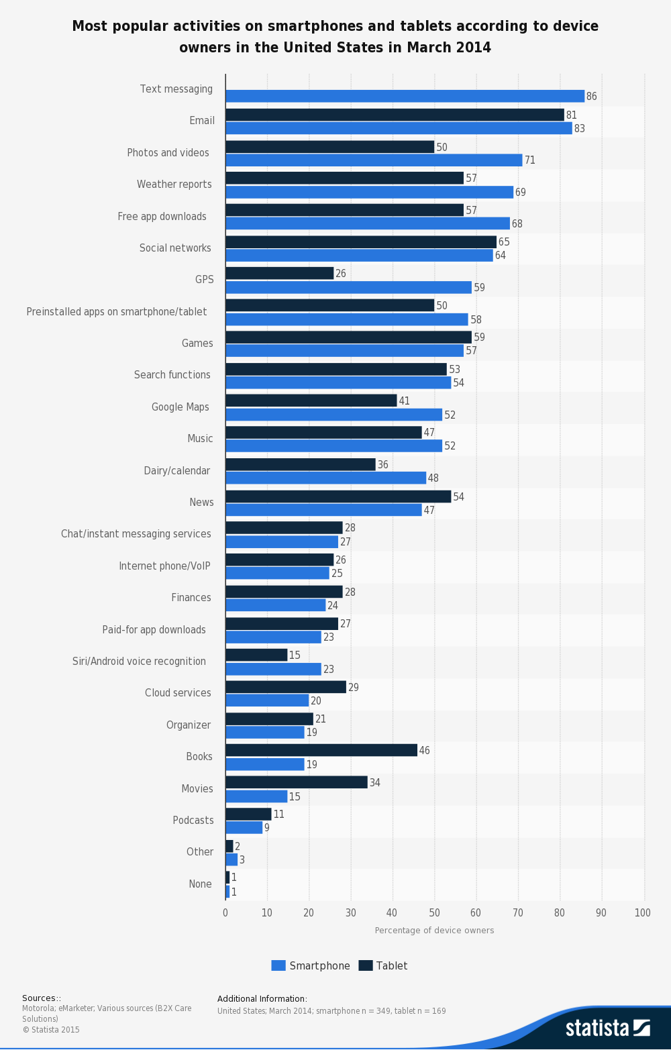

people taking photos – by gender

<https://www.statista.com/statistics/446502/us-smartphone-photos-gender/>

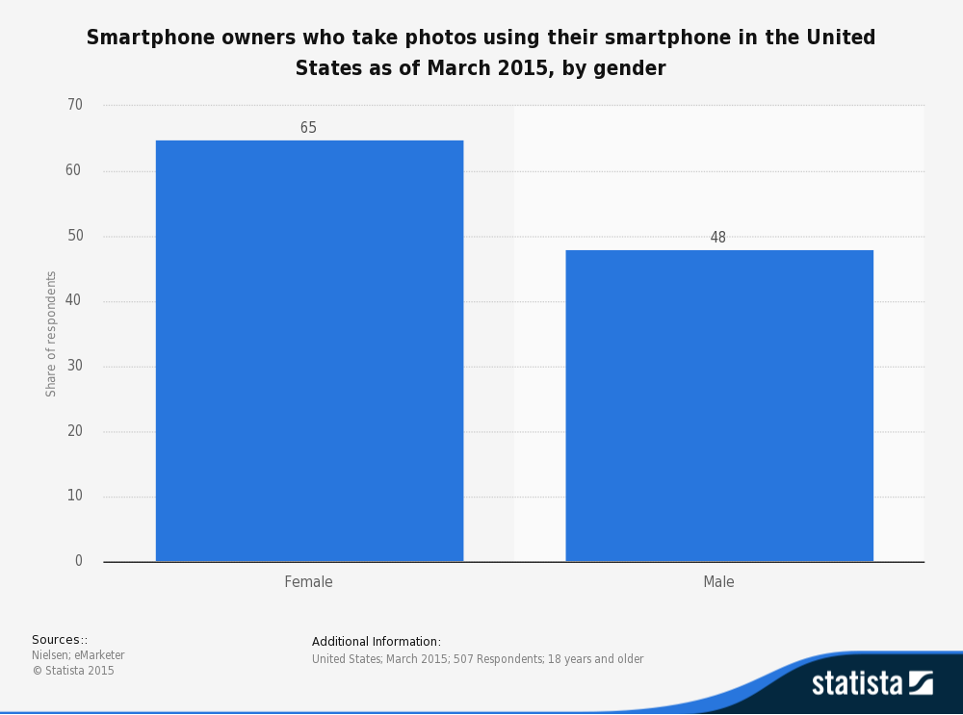

people taking photos – by age

<https://www.statista.com/statistics/446529/us-smartphone-owners-who-take-photos-with-their-smartphone-by-age/>

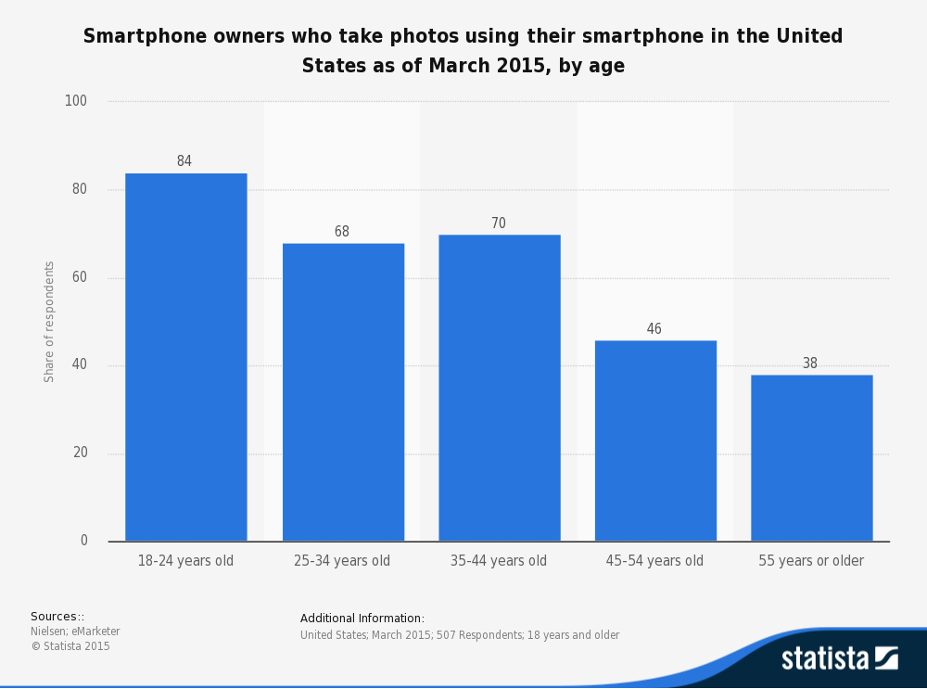

**Go to Market Strategy**

**Plan A: Growth Stage**

1. Upload basic videos and photos- Fill the site to make it look busy.

Get subscribers to upload one pic in each category to complete their profile for on profile completion, chances are more for their profile to boost up to appear on opening the app.

1. Outreach those basic contents to Twitter and Facebook using the brand’s name (boost posts)

*Cost: $15840 (For FB, and Twitter) Based on the survey*

|  |  |  |  |  |
| --- | --- | --- | --- | --- |
| Gender | Age | Post per month/cost | Cost | Audience reached (max limit) |
| Female | 18-24 |  | 200 | 63k |
| Female | 25-34 |  | 80 | 31k |
| Female | 35-44 |  | 80 | 31k |
| Female | <45 |  | 40 | 31k – 2 posts / month |
| Male | 18-24 |  | 100 | 63k |
| Male | 25-34 |  | 80 | 31k |
| Male | 35-44 |  | 40 | 31k |
| Male | <45 |  | 40 | 31k |
|  |  |  | Total: 660 $ |  |

For one platform – cost is 660$ per month.

We will boost posts on our facebook and twitter pages.

Total cost for a year will be: 660*12(months)*2 (facebook+twitter) =15,840 $

3.Track specific groups on twitter/Instagram and pull them in personally via e - mail/DM/twitter.

Allocated 2 people as Intern to do this work with wage:

9.5(hrs)*4(hrs/day)*5(working days/week)*12(months employed)*2(no. of interns) = 4560 $

4.Retain users by creating weekly activities (weekly themes) and encouraging contribution to the website and observe user analytics

This Analysis will be based on promotions for facebook gives such stats with every posts and interns will be doing this.

**Plan B: Brand attraction/promotion Stage**

1.Analyze where certain brands and companies are headed and set themes accordingly

2. Use twitter to approach brands and companies.

Interns job.

3. Advertise the site as is on social media

Facebook: 3650$ per year

Twitter: 0.5(ad cost)*4*12(months)=24-192 $ per year

2. Let the users come and contribute themselves to the site n/a

3. Contact brands directly about app purpose.

Additional Income Cost

**Integration of customer and supplier algorithms and analytics**

**Financials**

**1.Balance Sheet**

|  |  |
| --- | --- |
| **Assets** | ___________ |
| Current Assets | ___________ |
| Cash | ___________ |
| Inventory | ___________ |
| Other Current Assets | ___________ |
| **Total Current Assets** | ___________ |
| Long-term Assets |  |
| Long-term Assets | ___________ |
| Accumulated Depreciation | ___________ |
| **Total Long-term Assets** | ___________ |
| **Total Assets** | ___________ |
| **Liabilities and Capital** | ___________ |
| Current Liabilities | ___________ |
| Accounts Payable | ___________ |
| Current Borrowing | ___________ |
| Other Current Liabilities | ___________ |
| **Subtotal Current Liabilities** | ___________ |
| Long-term Liabilities | ___________ |
| **Total Liabilities** | ___________ |
| Paid-in Capital | ___________ |
| Retained Earnings | ___________ |
| Earnings | ___________ |
| **Total Capital** | ___________ |
| **Total Liabilities and Capital** | ___________ |
| **Net Worth** | ___________ |

**2.Income statement**

|  |  |
| --- | --- |
| **Sales** |  |
| Direct Cost of Sales |  |
| Other Production Expenses(Priniting) |  |
| Total Cost of Sales |  |
| Gross Margin |  |
| Gross Margin % |  |
| **Expenses** |  |
| Payroll           (for 9 employees) | (25000*12)  3,00,000  210,720  (manager & HR excluding) |
| Marketing & Other Expenses (ads+promotions) | 19682 |
| Depreciation |  |
| Lease | 1000 |
| Utilities | 125*80*11 |
|  |  |
| Rent: (12 months) | (2000*12)  24,000 |
| Pay  roll Taxes: | 240 |
| Third party cost (partnership with alamy) |  |
| Server (per year) | 600-1200 |
| Bank charges |  |
| Travel Expense/allowance | 6,000 |
| Insurance (employee ) | 3000*10  30,000 |
| R&D Costing | 4,800 |
| **Total Operating Expenses** |  |
| Profit Before Interest & Taxes | ___________ |
|  |  |
| Interest Expense | ___________ |
| Taxes Incurred | ___________ |
| **Net Profit** | ___________ |
| **Net Profit/Sales** | ___________ |

**Per month : 15,580 sales to be made.**

**3.Cash flow**

|  |  |
| --- | --- |
| **Cash Received** | ___________ |
| Cash from Operations | ___________ |
| Cash Sales | ___________ |
| **Subtotal Cash from Operations** | ___________ |
| Additional Cash Received | ___________ |
| Sales Tax, VAT, HST/GST Received | ___________ |
| New Current Borrowing | ___________ |
| New Other Liabilities (interest-free) | ___________ |
| New Long-term Liabilities | ___________ |
| Sales of Other Current Assets | ___________ |
| Sales of Long-term Assets | ___________ |
| New Investment Received | ___________ |
| **Subtotal Cash Received** | ___________ |
| **Expenditures** | ___________ |
| Expenditures from Operations | ___________ |
| Cash Spending | ___________ |
| Bill Payments | ___________ |
| **Subtotal Spent on Operations** | ___________ |
| Additional Cash Spent | ___________ |
| Sales Tax, VAT, HST/GST Paid Out | ___________ |
| Principal Repayment of Current Borrowing | ___________ |
| Other Liabilities Principal Repayment | ___________ |
| Long-term Liabilities Principal Repayment | ___________ |
| Purchase Other Current Assets | ___________ |
| Purchase Long-term Assets | ___________ |
| Dividends | ___________ |
| **Subtotal Cash Spent** | ___________ |
| **Net Cash Flow** | ___________ |
| **Cash Balance** | ___________ |

**Funding requirements and sources of funding**

Sources can be as follows:

**1.Crowd Funding and Angel Investors** [Set a goal of amount to be raised by this]

While most websites don't prohibit from posting to more than one funding platform at a time, posting on multiple sites can hurt your campaign for the campaign get diluted and distributed and one may end up getting lower than expected. There are not masses of random strangers browsing crowdfunding portals, looking for projects to back, the same people may be in two different crowdfunding sites hence sticking to one site may be best but applying to more may end up us getting better amount.

[to run a campaign you need to have a PR]

a)Microventures

**What it is:** MicroVentures is an [equity crowdfunding](https://en.wikipedia.org/wiki/Equity_crowdfunding) website offering investments in early stage companies. MicroVentures connects accredited investors with startups, businesses and services looking to raise funds or participate in select [secondary market](https://en.wikipedia.org/wiki/Secondary_market) opportunities. It helps start up connect with angel investors.

[Angel Investor is an affluent individual who provides capital for a business [start-up](https://en.wikipedia.org/wiki/Startup_company), usually in exchange for [convertible debt](https://en.wikipedia.org/wiki/Convertible_debt) or [ownership equity](https://en.wikipedia.org/wiki/Ownership_equity).]

**How it works:**

The average company listed on MicroVentures raises $250,000.

MicroVentures looks at prospective early stage companies using a variety of success criteria – such as suitable risk, likelihood of profitability.

Microventures takes a 10% fee (5% from the issuer and 5% from investors) from each successful raise plus 10% [carry](https://en.wikipedia.org/wiki/Carried_interest). If the full amount of an offering is not raised, then all investor money is returned.

MicroVentures speaks to every investor who signs up by phone to determine that they are accredited investors or meet suitability requirements. MicroVentures counts more than 10,000 accredited investors on the platform, including a "meaningful number" of international investors. The typical minimum investment is $5,000.

b)Kickstarter (not so good)

**What it is:** It is a global [crowdfunding](https://en.wikipedia.org/wiki/Crowdfunding) platform focused on creativity.

**How it works:**

Project creators choose a deadline and a minimum funding goal. If the goal is not met by the deadline, no funds are collected, a kind of [assurance contract](https://en.wikipedia.org/wiki/Assurance_contract).

Kickstarter applies a 5% fee on the total amount of the funds raised. Their payments processor applies an additional 3–5% fee.

Most raise between $1,000 and $9,999.

c)Indiegogo

**What it is:** Crowd funding site that runs on a rewards-based system, meaning donors, investors, or customers who are willing help to fund a project or product can donate and receive a gift, rather than an equity stake in the company.

**How it works:**

Users can create a page for their funding campaign, set up an account with [PayPal](https://en.wikipedia.org/wiki/PayPal), make a list of "perks" for different levels of investment, then create a [social media](https://en.wikipedia.org/wiki/Social_media)–based publicity effort. Users publicize the projects themselves—through [Facebook](https://en.wikipedia.org/wiki/Facebook), [Twitter](https://en.wikipedia.org/wiki/Twitter) and similar platforms. The site levies a 5% fee for successful campaigns. For campaigns that fail to raise their target amount, users have the option of either refunding all money to their contributors at no charge or keeping all money raised minus a 9% fee.[[22]](https://en.wikipedia.org/wiki/Indiegogo#cite_note-22) Unlike similar sites such as [Kickstarter](https://en.wikipedia.org/wiki/Kickstarter), Indiegogo disburses the funds immediately, when the contributions are collected through the user's PayPal accounts. Indiegogo also offers direct credit card payment acceptance through their own portal. Those funds are disbursed up to two weeks after the conclusion of a campaign.

It raised $ 4,511,301 for a film campaign.

**2.Bank Loan**

SBA

The Small Business Administration is a United States government agency that provides support to entrepreneurs and small businesses

SBA loans are made through banks, credit unions and other lenders who partner with the SBA. The SBA provides a government-backed guarantee on part of the loan.

<https://www.sba.gov/starting-business/finance-your-business/loans/sba-loans>

[Microloan Program](https://www.sba.gov/content/microloan-program) - borrowers in amounts up to a maximum of $50,000 ($35,000 to $50,000).

**3.Personal Investments from individuals**

<https://www.startengine.com/startup/snapwire-media-inc/financing-and-risks>

get the people to invest